23CSE202 DATABASE MANAGEMENT SYSTEMS
S3 B.Tech CSE
Department of Computer Science and Engineering
Amrita School of Computing, Amritapuri Campus

3. Database Design Document

Group No : D7
Team Members :
Roll No | Student Name
AM.SC.U4CSE25358 | Vyshnavi Rajith
AM.SC.U4CSE25350 | Sivatheerdha C A
AM.SC.U4CSE25321 | Harinarayan N
AM.SC.U4CSE25331 | Thanmai Mathi
AM.SC.U4CSE25307 | B Dinesh

Project Title : Blood Bank Management System

3.1. Detailed description of the project
[clearly describe the scenario so that the entities, attributes, relationships, users and business rules are evident from the description]
1. Project Scenario
The Blood Bank Management System is a centralized database system designed to manage hospitals, staff, donors, recipients, donation camps, blood donations, blood groups, blood stock, and blood requests. It addresses difficulties in manual management by maintaining donor information, monitoring blood availability, processing requests, and keeping records accurate and consistent.
Hospitals employ staff and admit recipients. Donors are associated with a blood group and may participate in multiple donation activities. Each donation is stored as a donation record linked to a donation camp. Hospitals maintain blood stock for different blood groups.
When a recipient needs blood, a blood request records the required blood group, number of units, priority, date, and status. The request is linked to the recipient, hospital, and processing staff member. The UI supports Donor Management, Recipient Management, Blood Stock, Blood Requests, Donation History, Hospital Management, Reports, and Settings.
2. Entities and Attributes
The ER diagram contains the following nine main entities.
a)HOSPITAL
- hospital_id – Primary Key: unique hospital identifier.
- name, address, phone, email
- total_beds, available_beds
- status, emergency_support

b) STAFF
- staff_id – Primary Key: unique staff identifier.
- hospital_id – Foreign Key to HOSPITAL
- name, email, password, phone, role

c)RECIPIENT
- recipient_id – Primary Key
- name, age, gender
- blood_group_needed – Foreign Key to BLOOD_GROUP
- hospital_id – Foreign Key to HOSPITAL
- attending_doctor_id – Foreign Key to STAFF
- date_registered

d)DONOR
- donor_id – Primary Key
- name, age, gender
- blood_group_code – Foreign Key to BLOOD_GROUP
- phone, email, address
- last_donation_date, eligibility_status

e) BLOOD_GROUP
blood_group_code – Primary Key. Supported groups: A+, A-, B+, B-, AB+, AB-, O+, O-.

f) DONATION_CAMP
- camp_id – Primary Key
- name, location, organizer
- camp_date, time_slot, target_units

g) DONATION_RECORD
- donation_id – Primary Key
- donor_id – Foreign Key to DONOR
- camp_id – Foreign Key to DONATION_CAMP
- units_donated, donation_date, status

h) BLOOD_STOCK
- stock_id – Primary Key
- hospital_id – Foreign Key to HOSPITAL
- blood_group_code – Foreign Key to BLOOD_GROUP
- units_available, target_capacity, last_updated
- UNIQUE(hospital_id, blood_group_code)

i) BLOOD_REQUEST
- request_id – Primary Key
- recipient_id – Foreign Key to RECIPIENT
- hospital_id – Foreign Key to HOSPITAL
- blood_group_code – Foreign Key to BLOOD_GROUP
- units_needed, priority, request_date, status
- processed_by_staff_id – Foreign Key to STAFF

3. Relationships and Cardinalities
a) HOSPITAL — employs — STAFF
Cardinality: 1 : N
One hospital employs many staff members, while each staff member belongs to one hospital.
Relationship:
HOSPITAL (1) → STAFF (N)

b) HOSPITAL — admits — RECIPIENT
Cardinality: 1 : N
One hospital can admit many recipients, while each recipient is admitted to one hospital.
Relationship:
HOSPITAL (1) → RECIPIENT (N)

c)STAFF — attends — RECIPIENT
Cardinality: 1 : N
One staff member can attend multiple recipients, while each recipient is associated with one attending staff member.
Relationship:
STAFF (1) → RECIPIENT (N)

d)RECIPIENT — initiates — BLOOD_REQUEST
Cardinality: 1 : N
One recipient can initiate multiple blood requests, while every blood request is associated with one recipient.
Relationship:
RECIPIENT (1) → BLOOD_REQUEST (N)

e) STAFF — processes — BLOOD_REQUEST
Cardinality: 1 : N
One staff member can process multiple blood requests, while each blood request is processed by one staff member.
Relationship:
STAFF (1) → BLOOD_REQUEST (N)

f) HOSPITAL — submits — BLOOD_REQUEST
Cardinality: 1 : N
One hospital can submit multiple blood requests, while each blood request is submitted by one hospital.
Relationship:
HOSPITAL (1) → BLOOD_REQUEST (N)

g) RECIPIENT — needed_by — BLOOD_GROUP
Cardinality: N : 1
Many recipients can require the same blood group, while each recipient has one specified blood group needed.
Relationship:
RECIPIENT (N) → BLOOD_GROUP (1)

h)BLOOD_REQUEST — of_type — BLOOD_GROUP
Cardinality: N : 1
Many blood requests can be made for the same blood group, while each request is for one blood group.
Relationship:
BLOOD_REQUEST (N) → BLOOD_GROUP (1)

i)DONOR — belongs_to — BLOOD_GROUP
Cardinality: N : 1
Many donors may belong to the same blood group, while each donor has one recorded blood group.
Relationship:
DONOR (N) → BLOOD_GROUP (1)

j) BLOOD_STOCK — belongs_to — BLOOD_GROUP
Cardinality: N : 1
Multiple stock records can correspond to the same blood group, while each stock record represents one blood group.
Relationship:
BLOOD_STOCK (N) → BLOOD_GROUP (1)

k) HOSPITAL — maintains — BLOOD_STOCK
Cardinality: 1 : N
One hospital can maintain multiple blood-stock records, while each stock record belongs to one hospital.
Relationship:
HOSPITAL (1) → BLOOD_STOCK (N)

l)DONATION_CAMP — hosts — DONATION_RECORD
Cardinality: 1 : N
One donation camp can host multiple donation records, while each donation record is associated with one camp.
Relationship:
DONATION_CAMP (1) → DONATION_RECORD (N)

m)DONOR — makes — DONATION_RECORD
Cardinality: 1 : N
One donor can make multiple donations over time, while each donation record belongs to one donor.
Relationship:
DONOR (1) → DONATION_RECORD (N)

4. System Users
- Administrator / Authorized Staff: maintains donor records, updates blood stock, processes requests, and monitors blood availability.
- Hospital Personnel: manage recipients and submit blood requests using hospital, recipient, and request information.
- Authorized Medical Personnel: participate in recipient management and blood-request activities, including verifying availability and tracking request status.

5. Business Rules
- Every hospital, staff member, recipient, donor, donation, camp, request, and stock record has a unique identifier.
- A hospital can employ multiple staff members, admit multiple recipients, submit multiple requests, and maintain multiple stock records.
- Each staff member belongs to one hospital; staff roles determine permitted operations.
- Each recipient belongs to one hospital, has one required blood group and one attending staff member, and may initiate multiple requests.
- Each donor belongs to one blood group and may make multiple donations. Donor last_donation_date and eligibility_status are maintained.
- Each donation record belongs to one donor and one donation camp; a camp may host multiple records.
- Each blood group has a unique blood_group_code and may be referenced by donors, recipients, requests, and stock.
- Each stock record belongs to one hospital and one blood group. units_available stores the current quantity and stock can be increased, decreased, or updated.
- Each blood request belongs to one recipient and hospital, specifies one blood group and units_needed, has priority, request_date, and status, and is processed by staff. Request classifications include Pending, Approved, Rejected, Emergency, and High Priority.

6. Overall Database Workflow
Hospital → Staff / Recipient / Blood Stock / Blood Request
Donor → Donation Record → Donation Camp
Donor → Blood Group
Recipient → Required Blood Group
Blood Request → Required Blood Group

3.2. ER Diagram
[entities, attributes, relationships, keys, cardinality and participation have to be accurately represented]

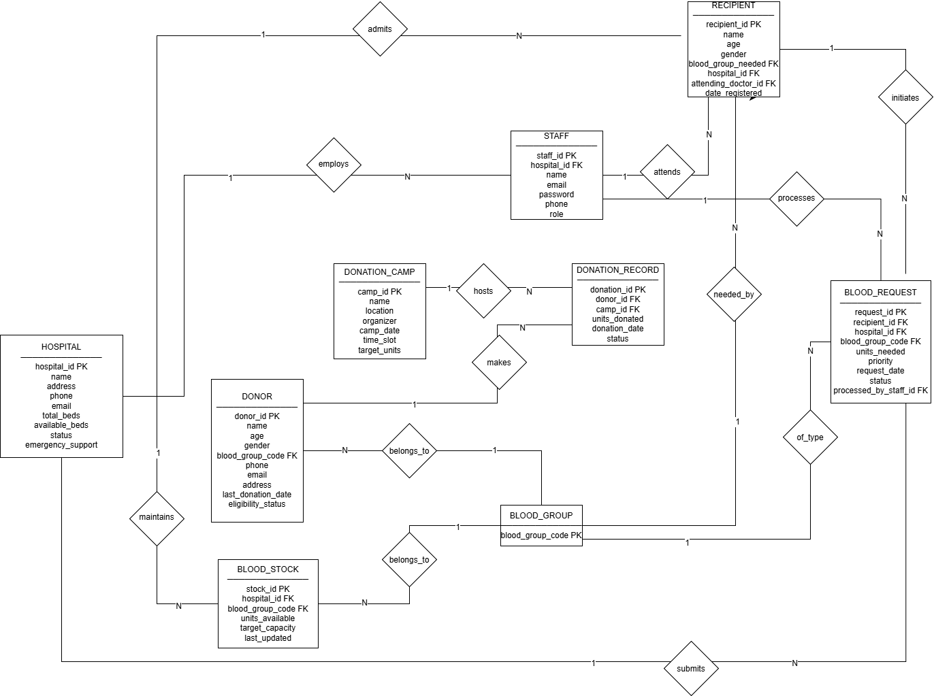

3.3 Relational Schema
[Correctly converts all entities, relationships, cardinality etc to relational schema]
HOSPITAL(
hospital_id INT PRIMARY KEY,
name VARCHAR(100),
address VARCHAR(255),
phone VARCHAR(15),
email VARCHAR(100),
total_beds INT,
available_beds INT,
status VARCHAR(20),
emergency_support BOOLEAN
)

BLOOD_GROUP(
blood_group_code VARCHAR(3) PRIMARY KEY
)

DONOR(
donor_id INT PRIMARY KEY,
name VARCHAR(100),
age INT,
gender VARCHAR(10),
blood_group_code VARCHAR(3),
phone VARCHAR(15),
email VARCHAR(100),
address VARCHAR(255),
last_donation_date DATE,
eligibility_status VARCHAR(20),

FOREIGN KEY (blood_group_code)
REFERENCES BLOOD_GROUP(blood_group_code)
)

DONATION_CAMP(
camp_id INT PRIMARY KEY,
name VARCHAR(100),
location VARCHAR(255),
organizer VARCHAR(100),
camp_date DATE,
time_slot VARCHAR(50),
target_units INT
)

DONATION_RECORD(
donation_id INT PRIMARY KEY,
donor_id INT,
camp_id INT,
units_donated INT,
donation_date DATE,
status VARCHAR(20),

FOREIGN KEY (donor_id)
REFERENCES DONOR(donor_id),

FOREIGN KEY (camp_id)
REFERENCES DONATION_CAMP(camp_id)
)
STAFF(
staff_id INT PRIMARY KEY,
hospital_id INT,
name VARCHAR(100),
email VARCHAR(100),
password VARCHAR(255),
phone VARCHAR(15),
role VARCHAR(50),

FOREIGN KEY (hospital_id)
REFERENCES HOSPITAL(hospital_id)
)

RECIPIENT(
recipient_id INT PRIMARY KEY,
name VARCHAR(100),
age INT,
gender VARCHAR(10),
blood_group_needed VARCHAR(3),
hospital_id INT,
attending_doctor_id INT,
date_registered DATE,

FOREIGN KEY (blood_group_needed)
REFERENCES BLOOD_GROUP(blood_group_code),

FOREIGN KEY (hospital_id)
REFERENCES HOSPITAL(hospital_id),

FOREIGN KEY (attending_doctor_id)
REFERENCES STAFF(staff_id)
)

BLOOD_REQUEST(
request_id INT PRIMARY KEY,
recipient_id INT,
hospital_id INT,
blood_group_code VARCHAR(3),
units_needed INT,
priority VARCHAR(20),
request_date DATE,
status VARCHAR(20),
processed_by_staff_id INT,

FOREIGN KEY (recipient_id)
REFERENCES RECIPIENT(recipient_id),

FOREIGN KEY (hospital_id)
REFERENCES HOSPITAL(hospital_id),

FOREIGN KEY (blood_group_code)
REFERENCES BLOOD_GROUP(blood_group_code),

FOREIGN KEY (processed_by_staff_id)
REFERENCES STAFF(staff_id)
)
BLOOD_STOCK(
stock_id INT PRIMARY KEY,
hospital_id INT,
blood_group_code VARCHAR(3),
units_available INT,
target_capacity INT,
last_updated DATE,

FOREIGN KEY (hospital_id)
REFERENCES HOSPITAL(hospital_id),

FOREIGN KEY (blood_group_code)
REFERENCES BLOOD_GROUP(blood_group_code),

UNIQUE(hospital_id, blood_group_code)
)

3.4 Normalization and Functional dependency analysis
[Correctly identifies relevant FDs and explains their significance
Justify the selection of candidate keys with attribute closure
Demonstrate the normalization process starting from 1NF to BCNF or higher with proper justification]
The database is normalized from 1NF to 2NF, 3NF, and BCNF. The analysis considers all nine relations: HOSPITAL, BLOOD_GROUP, DONOR, DONATION_CAMP, DONATION_RECORD, STAFF, RECIPIENT, BLOOD_REQUEST, and BLOOD_STOCK.
1. FIRST NORMAL FORM (1NF)
All attributes in the nine relations contain atomic values, and each relation has a defined primary/candidate key. Therefore, all nine relations satisfy 1NF.
BLOOD_STOCK has primary key stock_id and also the unique combination (hospital_id, blood_group_code), giving it two candidate keys.

Functional Dependencies
Relation | Functional Dependency
HOSPITAL | hospital_id → name, address, phone, email, total_beds, available_beds, status, emergency_support
BLOOD_GROUP | blood_group_code → no non-key attributes
DONOR | donor_id → name, age, gender, blood_group_code, phone, email, address, last_donation_date, eligibility_status
DONATION_CAMP | camp_id → name, location, organizer, camp_date, time_slot, target_units
DONATION_RECORD | donation_id → donor_id, camp_id, units_donated, donation_date, status
STAFF | staff_id → hospital_id, name, email, password, phone, role
RECIPIENT | recipient_id → name, age, gender, blood_group_needed, hospital_id, attending_doctor_id, date_registered
BLOOD_REQUEST | request_id → recipient_id, hospital_id, blood_group_code, units_needed, priority, request_date, status, processed_by_staff_id
BLOOD_STOCK | stock_id → hospital_id, blood_group_code, units_available, target_capacity, last_updated
BLOOD_STOCK (UNIQUE constraint) | (hospital_id, blood_group_code) → stock_id, units_available, target_capacity, last_updated

Candidate Keys
Relation | Candidate Key(s)
HOSPITAL | {hospital_id}
BLOOD_GROUP | {blood_group_code}
DONOR | {donor_id}
DONATION_CAMP | {camp_id}
DONATION_RECORD | {donation_id}
STAFF | {staff_id}
RECIPIENT | {recipient_id}
BLOOD_REQUEST | {request_id}
BLOOD_STOCK | {stock_id}, {hospital_id, blood_group_code}

Attribute Closure
HOSPITAL: {hospital_id}+ = {hospital_id, name, address, phone, email, total_beds, available_beds, status, emergency_support}.
This is the full attribute set, and hospital_id is minimal; therefore {hospital_id} is a candidate key.
BLOOD_GROUP: {blood_group_code}+ = {blood_group_code}.
Since this is the complete attribute set, {blood_group_code} is a candidate key.
DONOR: {donor_id}+ = {donor_id, name, age, gender, blood_group_code, phone, email, address, last_donation_date, eligibility_status}.
This is the full attribute set; therefore {donor_id} is a candidate key.
DONATION_CAMP: {camp_id}+ = {camp_id, name, location, organizer, camp_date, time_slot, target_units}.
This is the full attribute set; therefore {camp_id} is a candidate key.
DONATION_RECORD: {donation_id}+ = {donation_id, donor_id, camp_id, units_donated, donation_date, status}.
This is the full attribute set; therefore {donation_id} is a candidate key.
STAFF: {staff_id}+ = {staff_id, hospital_id, name, email, password, phone, role}. This is the full attribute set; therefore {staff_id} is a candidate key.
RECIPIENT: {recipient_id}+ = {recipient_id, name, age, gender, blood_group_needed, hospital_id, attending_doctor_id, date_registered}.
This is the full attribute set; therefore {recipient_id} is a candidate key.
BLOOD_REQUEST: {request_id}+ = {request_id, recipient_id, hospital_id, blood_group_code, units_needed, priority, request_date, status, processed_by_staff_id}.
This is the full attribute set; therefore {request_id} is a candidate key.
BLOOD_STOCK :
1. {stock_id}+ = {stock_id, hospital_id, blood_group_code, units_available, target_capacity, last_updated}. This is the full attribute set. Since stock_id is a single attribute, it is minimal; therefore {stock_id} is a candidate key.
2. {hospital_id, blood_group_code}+ = {hospital_id, blood_group_code, stock_id, units_available, target_capacity, last_updated}. The UNIQUE(hospital_id, blood_group_code) constraint implies that this combination determines the stock record. Its closure is the full attribute set.

2. SECOND NORMAL FORM (2NF)
All relations except BLOOD_STOCK have only single-attribute candidate keys, so partial dependencies cannot occur. BLOOD_STOCK has candidate keys stock_id and (hospital_id, blood_group_code). Neither hospital_id nor blood_group_code alone determines non-key attributes, while their combination determines the complete tuple. Hence there is no partial dependency.
Therefore, all nine relations satisfy 2NF.

3. THIRD NORMAL FORM (3NF)
For HOSPITAL, BLOOD_GROUP, DONOR, DONATION_CAMP, DONATION_RECORD, STAFF, RECIPIENT, and BLOOD_REQUEST, the determinant in each non-trivial FD is the candidate key and hence a superkey.
For BLOOD_STOCK, both stock_id and (hospital_id, blood_group_code) are candidate keys and therefore superkeys. Thus no non-key attribute transitively depends on a non-key determinant.
Therefore, all nine relations satisfy 3NF.

4. BOYCE-CODD NORMAL FORM (BCNF)
BCNF requires every determinant of a non-trivial functional dependency to be a superkey. In the first eight relations, the only determinants are their candidate keys. In BLOOD_STOCK, both determinants—stock_id and (hospital_id, blood_group_code)—are candidate keys.
Therefore, every determinant is a superkey, and all nine relations satisfy BCNF.

Conclusion
The Blood Bank Management System database satisfies the requirements
of 1NF, 2NF, 3NF and BCNF.

